UAS PRAKTIKUM

SISTEM DATABASE 2



Disusun oleh :

Naufal Ariful Amri (140810180009)

Alfari Sidnan Ghilmana (140810180011)

Ahmad Faaiz Al-auza’i (140810180023)

**PROGRAM STUDI S1 TEKNIK INFORMATIKA**

**DEPARTEMEN ILMU KOMPUTER**

**FAKULTAS MATEMATIKA DAN ILMU PENGETAHUAN ALAM**

**UNIVERSITAS PADJADJARAN**

1. **ERD & TABEL RELASI**

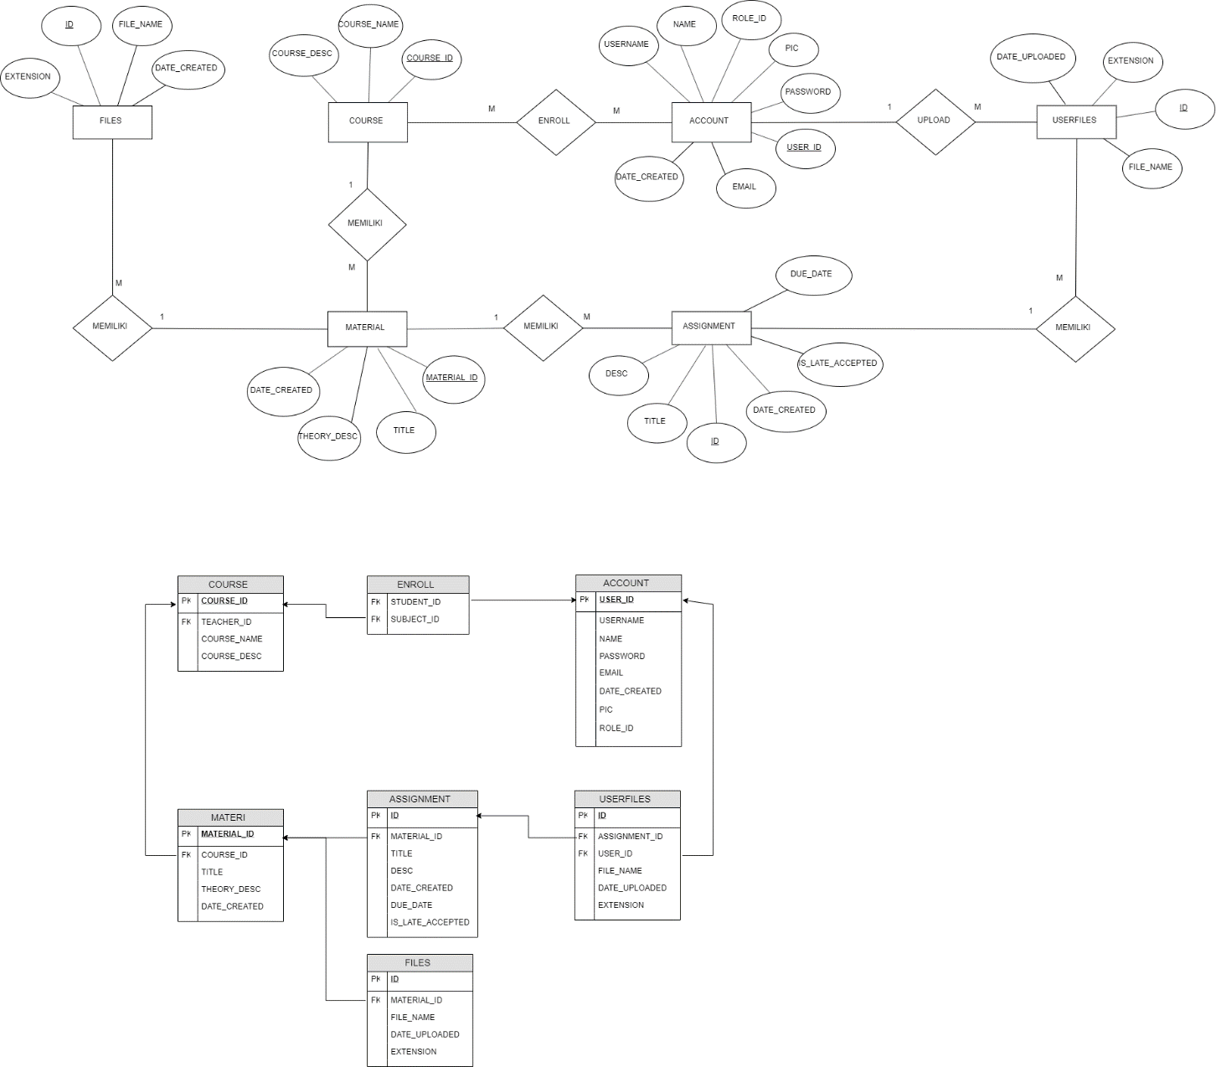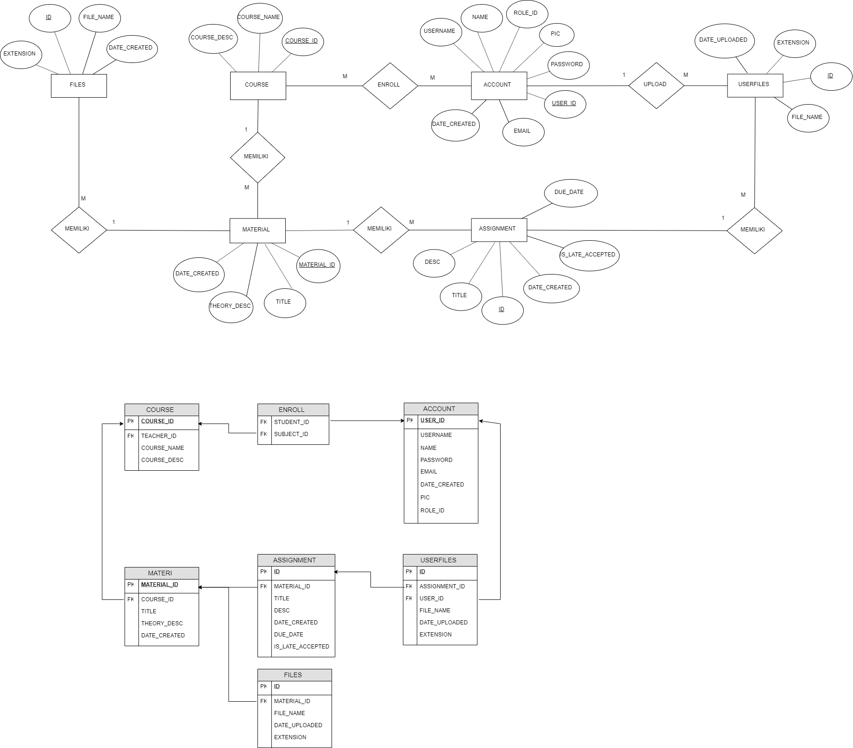

1. **KAMUS DATA**

Nama table : Account

Deskripsi : Menyimpan semua data user (student & teacher)

|  |  |  |  |
| --- | --- | --- | --- |
| No. | Nama Atribut | Tipe Data | Keterangan |
| 1 | User_id | Varchar(30) | Primary key tabel account |
| 2 | username | Varchar(12) | Username untuk login |
| 3 | Password | Varchar(128) | Password untuk login |
| 4 | email | Varchar(30) | Menyimpan email |
| 5 | Pic | Varchar (200) | Menyimpan nama data/gambar |
| 6 | Role_id | Varchar (1) | Check user/admin |
| 7 | Date_created | Varchar(30) | Menyimpan tanggal penyimpanan |

Nama table : Course

Deskripsi : Menyimpan data mata kuliah

|  |  |  |  |
| --- | --- | --- | --- |
| No. | Nama Atribut | Tipe Data | Keterangan |
| 1 | Course_id | Int auto_increment | Primary key tabel Course |
| 2 | Teacher_id | Varchar(20) | Foreign key table account (user_id) |
| 3 | Course_name | Varchar(32) | Nama mata kuliah |
| 4 | Course_desc | Varchar(200) | Deskripsi mata kuliah |
| 5 | Image | Varchar(250) | Menyimpan nama data/gambar tampilan |
| 6 | Icon | Varchar (50) | Menyimpan nama data/gambar icon |

Nama table : Enroll

Deskripsi : Menyimpan data mahasiswa yang meng-enroll mata kuliah

|  |  |  |  |
| --- | --- | --- | --- |
| No. | Nama Atribut | Tipe Data | Keterangan |
| 1 | Course_id | Int not null | Foreign key tabel Course (course_id) |
| 2 | Student_id | Varchar(20) | Foreign key table account (user_id) |

Nama tabel : Material

Deskripsi : Menyimpan materi kuliah

|  |  |  |  |
| --- | --- | --- | --- |
| No. | Nama Atribut | Tipe Data | Keterangan |
| 1 | Material_id | Int auto_increment | Primary key tabel Material |
| 2 | Course_id | Varchar(20) | PK composite table account (user_id) |
| 3 | Title | Varchar(200) | Judul Materi kuliah |
| 4 | Desc | Varchar(200) | Deskripsi materi kuliah |
| 5 | Date_created | Varchar(30) | Menyimpan tanggal penyimpanan |

Nama tabel : File

Deskripsi : Menyimpan file data upload materi

|  |  |  |  |
| --- | --- | --- | --- |
| No. | Nama Atribut | Tipe Data | Keterangan |
| 1 | Id | Int auto_increment | Primary Key table file |
| 2 | Material_id | Int not null | Foreign key table material (material_id) |
| 4 | File_name | Varchar(200) | Nama file yang disimpan |
| 5 | Extension | Varchar(20) | Menyimpan format file |
| 6 | Date_uploaded | Varchar(30) | Menyimpan data tanggal upload |

Nama table : Assignment

Deskripsi : Menyimpan data/kantong tugas

|  |  |  |  |
| --- | --- | --- | --- |
| No. | Nama Atribut | Tipe Data | Keterangan |
| 1 | Id | Int auto_increment | Primary Key table assignment |
| 2 | Material_id | Int not null | Foreign key table material (material_id) |
| 4 | Title | Varchar(200) | Menyimpan judul yang ditugaskan |
| 5 | Desc | Varchar(200) | Menyimpan deskripsi tugas |
| 6 | Due_date | Varchar(20) | Menyimpan deadline tugas |
| 7 | Date_created | Varchar(30) | Menyimpan data tanggal upload |
| 8 | Is_late_accepted | Int default 1 | Menyimpan data apakah terlambat. |

Nama table : Userfilse

Deskripsi : Menyimpan data submission yang diupload mahasiswa

|  |  |  |  |
| --- | --- | --- | --- |
| No. | Nama Atribut | Tipe Data | Keterangan |
| 1 | Id | Int auto_increment | Primary Key table userfiles |
| 2 | Assignment_id | Int not null | Foreign key table Assignment (id) |
| 3 | Student_id | Varchar(20) | Foreign key table course (user_id) |
| 4 | File_name | Varchar(200) | Menyimpan nama file yang dikumpulkan |
| 5 | Extension | Varchar(20) | Menyimpan format file |
| 6 | Date_uploaded | Varchar(20) | Menyimpan data tanggal upload |